

Project: Sports Fields Management System
Software Requirement Specification

- Hanoi, 2026 -

Record of changeS
Date | A*  M, D | In charge | Change Description
*A - Added M - Modified D - Deleted

Table of Contents
I. Overview 4
1. Introduction 4
2. User Requirements 4
2.1. Actors 4
2.2. Use Case 5
3. System Functions 9
3.1. Screen Flow 9
3.2. Screen Details 10
3.3. User Authorization 11
3.4. Non-Screen Functions 12
4. Entity Relationship Diagram 12
II. Functional Requirements 14
1. Login 14
2. Logout 15
3. Sign up 16
4. View Field List 17
5. View Field Detail 17
6. Search Field 18
7. Book Field 19
8. Receive Notification 20
9. Manage Customer Profile 21
10. View booking list 21
11. Manage booking field 22
12. Manage FeedBack 23
13. Manager field 24
14. CRUD field 24
15. Manage customer account 25
16. View dashboard 26
17. View revenue statistics (not yet implement) 27
18. Reset Customer Password 27
19. Reset Manager Password 28
20. Change Password 29
21. View booking details 30
22. Cancel booking 31
23. Create Feedback 31
24. Manage Manager Profile 32

I. Overview

1. Introduction
The San Sieu Toc is a centralized web-based sports facility management system designed to replace the inefficient manual, notebook-based, and telephone processes currently used for scheduling and managing sports fields. Operating on a B2C (Business-to-Customer) model, the system empowers the Facility Owner (Manager) to manage multiple branches and diverse sport categories (Football, Tennis, Pickleball) from a single dashboard.
The system is expected to streamline the reservation workflow through a flexible multi-slot booking mechanism, allowing customers to book multiple slots across different fields. Furthermore, it provides accurate weekly, monthly, and yearly revenue statistics and ultimately eliminates schedule conflicts (double-booking).
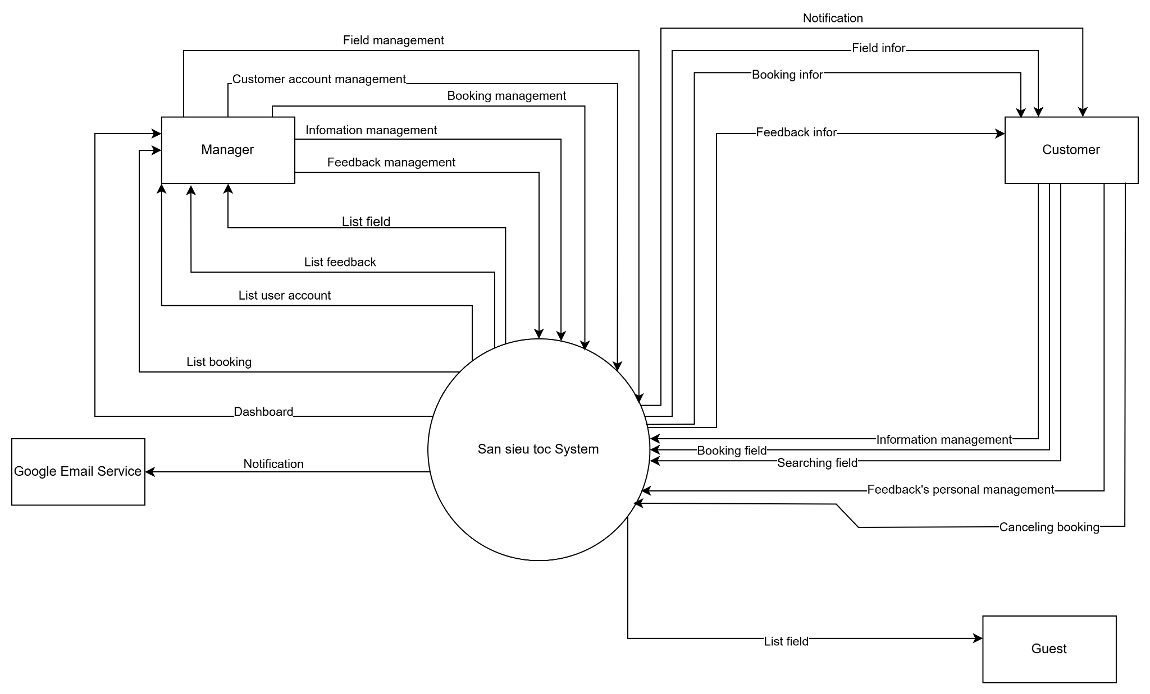
Figure I.1: Context diagram

2. User Requirements

2.1. Actors
Table I.1: Actor description
# | Actor | Description
1 | Manager | Represents the system administrator and facility owner. This actor has privileged access to the dashboard to create, update, or delete information regarding field locations (Field_Address), field types (FieldType), and specific fields (Field). They are also responsible for monitoring booking schedules, revenue, and managing the customer list.
2 | Customer | Represents a registered user who has logged into the system. This actor possesses full end-user capabilities: searching for fields, viewing details, making reservations (Booking), viewing booking history, and submitting reviews (Feedback) after using the service.
3 | Guest | Represents an unauthenticated visitor accessing the system without logging in. This actor has limited access privileges, such as browsing the landing page, viewing the list of fields, and searching by category or location. To book a field they are required to Register or Login to become a Customer.

2.2. Use Case

2.2.1. Use Case Diagram

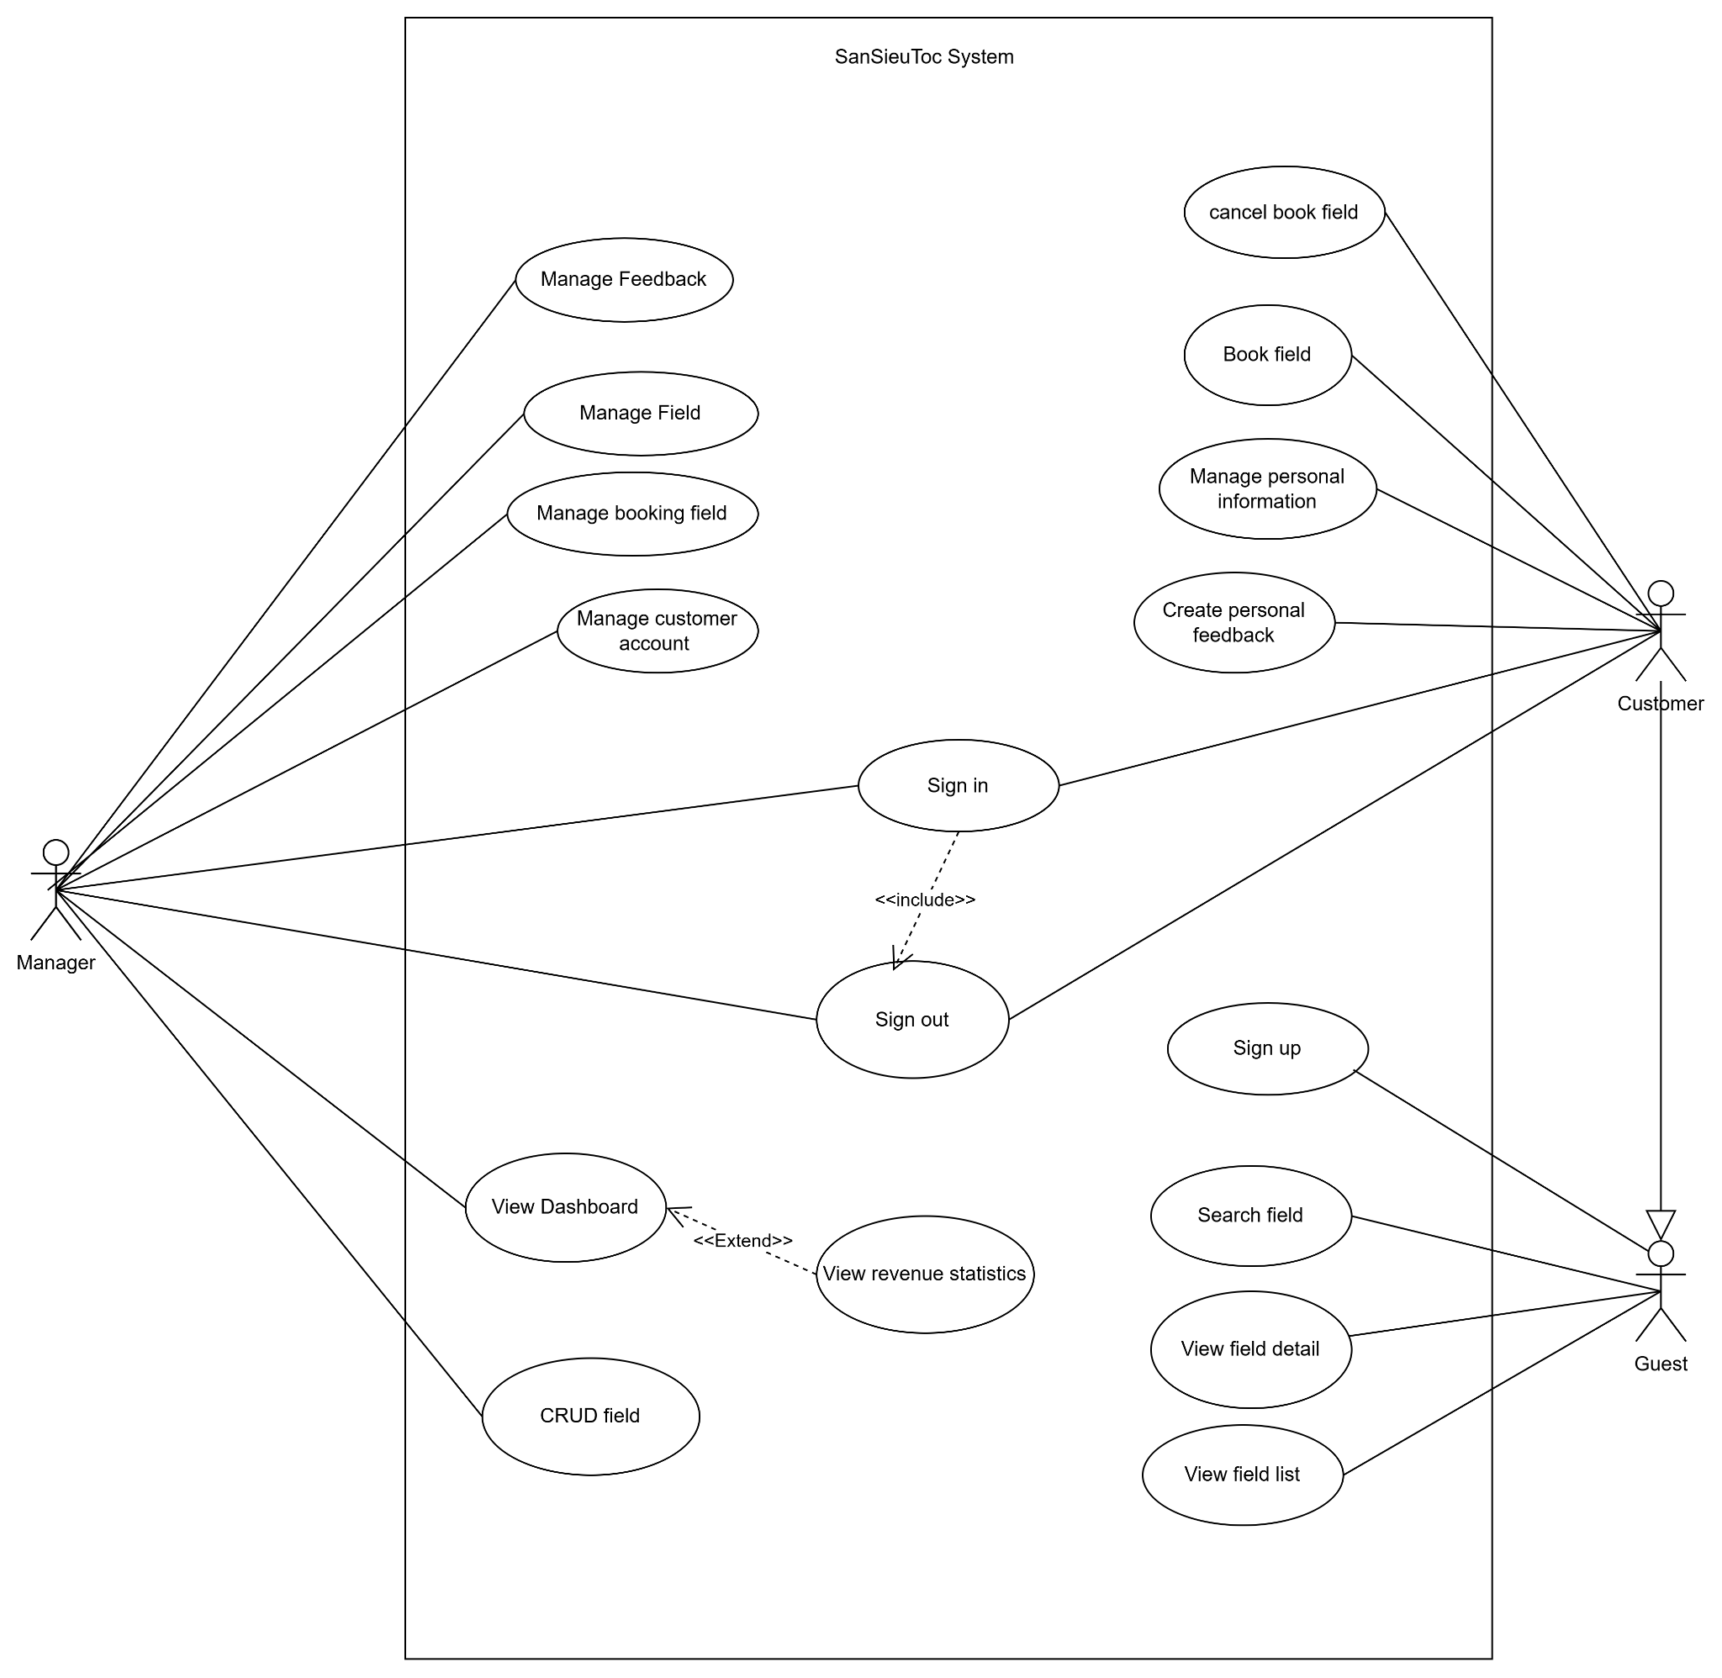
Figure I.2: Use case diagram
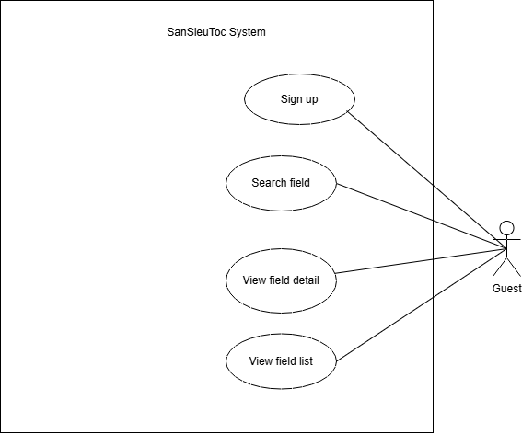
Figure I.3: Use case guest diagram

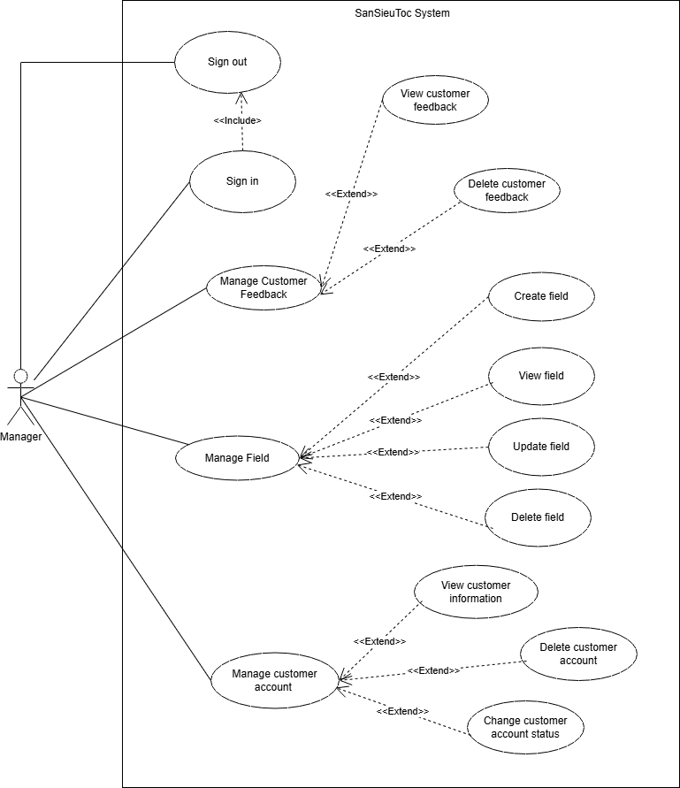
Figure I.4: Use case manager diagram

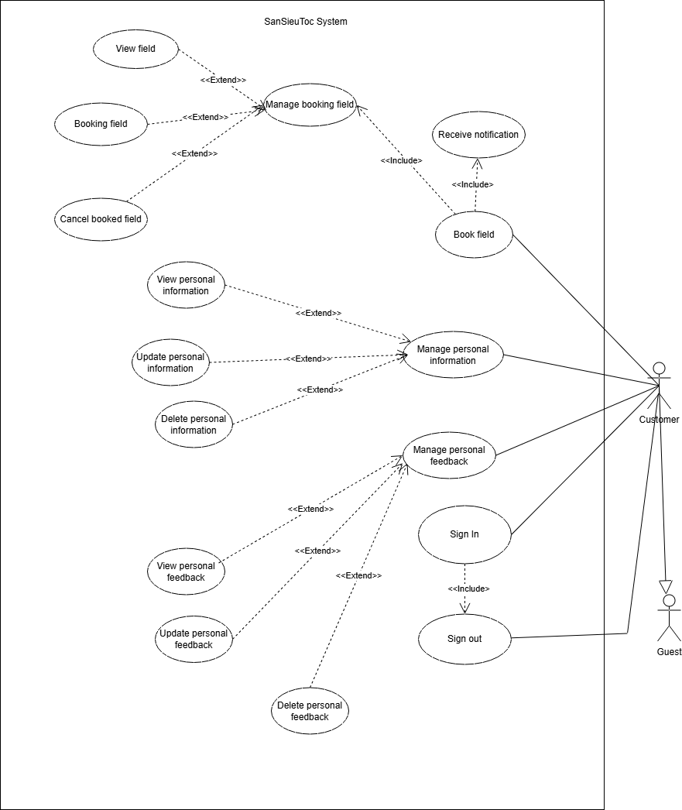
Figure I.5: Use case customer diagram

2.2.2. Use Case Description
Table I.2: Use case description
ID | Use Case | Actors | Use Case Description
01 | Login | Customer, Manager | User can login to use another features
02 | Logout | Customer, Manager | User logout system and back to guest's role
03 | Sign up | Guest | Allows guest to register a new account
04 | View field list | Guest, Customer | Displays a list of available fields
05 | View field detail | Guest, Customer | Displays detailed information of a selected field
06 | Search field | Guest, Customer | Allows user to search fields by criteria
07 | Book field | Customer | Allows customer to create a field booking request
08 | Receive notification | Customer | Allows customer to receive booking notifications
09 | Manage Customer Profile | Customer | Allows customers to update personal information.
10 | View booking list | Customer, Manager | Allows customer and manager to view field list.
11 | Manage booking field | Manager | Allows manager to approve or reject pending booking requests.
12 | Manage feedback | Manager | Allows manager to view and analyze customer feedback.
13 | Manage field | Manager | Allows manager to manage field information.
14 | CRUD field | Manager | Allows manager to create, update, or delete fields.
15 | Manage customer account | Manager | Allows manager to manage customer accounts.
16 | View dashboard | Manager | Displays system overview dashboard.
17 | View revenue statistics | Manager | Manager can see overall revenue cards as part of the dashboard.
18 | Reset customer password | Customer | Allows a customer to request a password reset via email.
19 | Reset manager password | Manager | Allows a manager to request a password reset via email.
20 | Change Password | Customer, Manager | Allows authenticated users to change their current password.
21 | View booking details | Customer | Displays detailed information of a specific booking.
22 | Cancel booking | Customer | Allows a customer to cancel a pending booking.
23 | Create feedback | Customer | Allows a customer to submit rating and comment for a completed booking/field.
24 | Manage manager profile | Manager | Allows managers to update their own profile information (name, phone, avatar, QR code).

3. System Functions

3.1. Screen Flow

3.1.1. Guest Flow
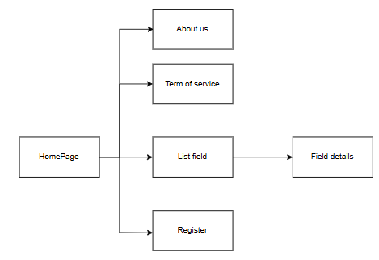
Figure I.6: Guest screen flow

3.1.2. Customer Flow
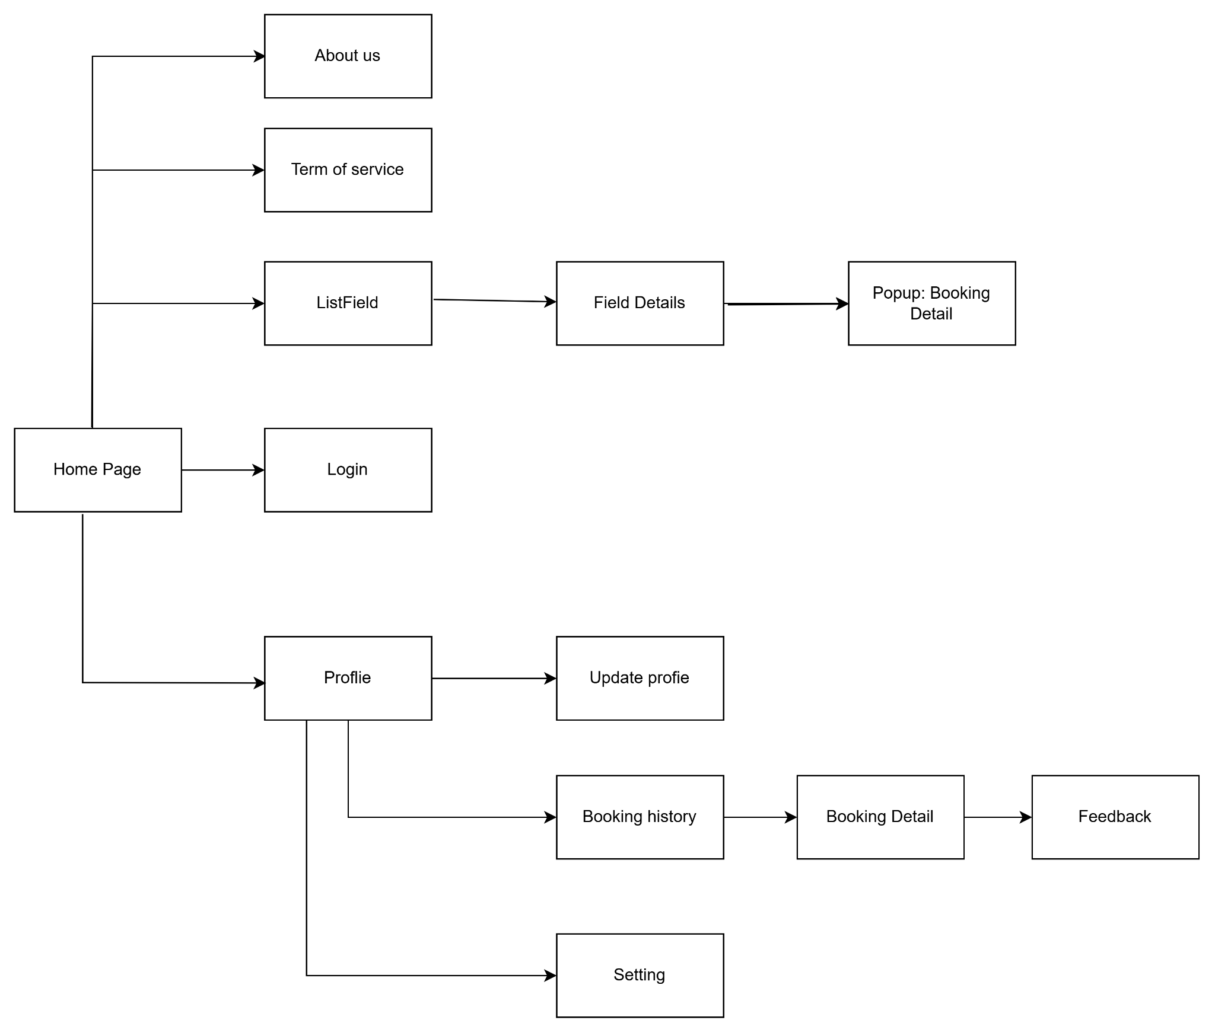
Figure I.7: Customer screen flow

3.1.3. Manager Flow
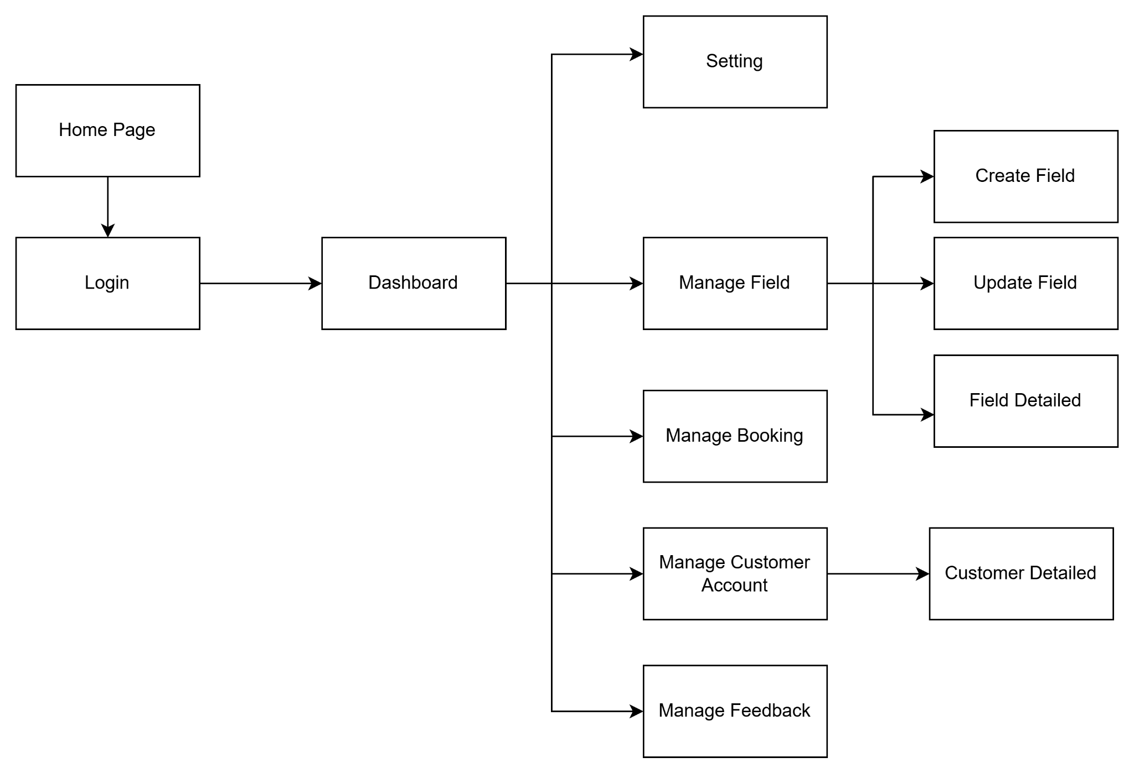
Figure I.8: Manager screen flow

3.2. Screen Details
Table I.3: Screen details
# | Feature | Screen | Description
1 | Login | Login | Login screen for user the system
2 | Register | Register | Register new account for customer
3 | Logout | Profile | Manager and Customer logout, return to guest role
4 | View profile | Profile | User can view their information in this screen
5 | Change password | Update Profile | User can change their password on system
6 | Reset password | Forgot Password | Users can reset their password if they forget it by using their email address
7 | Edit profile | Update Profile | Allow user update profile
8 | View home page | Home Page | Main interface with navigation bar and system introduction
9 | Search field | Home Page | Customer searching for a field by text, filter by price, category, fieldType, time
10 | View field list | Field List | Display list of available field
11 | View field details | Field Details | View field details: images, name, price, feedback, time slot, address, description, utilities
12 | Booking field | Booking | Allow customer to create a booking request for a field
13 | View booking history | Booking history | Customer view history booking field
14 | Cancel booking | Booking history | Customer can cancel booking field before manager accept
15 | Create feedback | Feedback | Customer can create feedback after experience field
16 | Edit feedback | Feedback | Customer can edit feedback themself
17 | Delete feedback | Feedback | Customer can delete feedback themself
18 | View dashboard | Dashboard | The manager checks the statistics on the number of land transactions, the number of properties, and the number of accounts.
19 | View list field | Manage field | The manager can control field
20 | Delete field | Manage field | The manager can delete field
21 | Update field | Update field | The manager change the field information
22 | Create field | Create field | The manager create new field on the list
23 | Manage booking | Manage booking | The manager view booking field of customer and change status booking
24 | Manage customer account | Manage customer account | The manager view customer account and ban customer account
25 | Manage feedback | Manage feedback | The manager view feedback and can delete feedback of customer
26 | About us | About us | Users can view introductory information about the website's past achievements.
27 | Term of service | Term of service | The terms that users must comply with when using the website.

3.3. User Authorization
Table I.4: User Authorization
Screen | Guest | Customer | Manager
Login |  | X | X
Register | X
Profile |  | X | X
Logout |  | X | X
View profile |  | X | X
Update Profile |  | X | X
Change password |  | X | X
Edit profile |  | X | X
Home Page | X | X | X
View home page | X | X | X
Search field | X | X | X
View field list | X | X | X
View field details | X | X | X
Booking field |  | X
Booking history |  | X
View booking history |  | X
Cancel booking |  | X
Feedback |  | X | X
Edit feedback |  | X
Delete feedback |  | X | X
View dash board |  |  | X
Manage field |  |  | X
View list field |  |  | X
Delete field |  |  | X
Update field |  |  | X
Create field |  |  | X
Manage booking |  |  | X
Manage customer account |  |  | X
Manage feedback |  |  | X
In which:
- Guest: People who don’t have an account on system want to have looking on web
- Customer: People who have an account on system and want to booking field sport
- Manager: People who is the owner or staff of sports field system

3.4. Non-Screen Functions
Table I.5: Non-Screen Function
# | Feature | System Function | Description
1 | Booking Management | Conflict Detection | When a court booking request is received, the system automatically scans the database to ensure that the time slot is not already booked (or is not locked).
2 | Notification System | Email Dispatcher | After the user forgot the password, the system will call a hidden email service to send a new password to the user's email address.
3 | Security & Auth | Token Verification Middleware | For each API request (except login/registration), the system implicitly checks the validity of the JWT (JSON Web Token) in the header to verify the user's identity and permissions before processing the data.
4 | Security & Auth | Password Hashing | When a user registers or changes their password, the system performs a hashing algorithm (e.g., bcrypt) before storing that string in MongoDB, ensuring that the password is not stored as plain text.

4. Entity Relationship Diagram

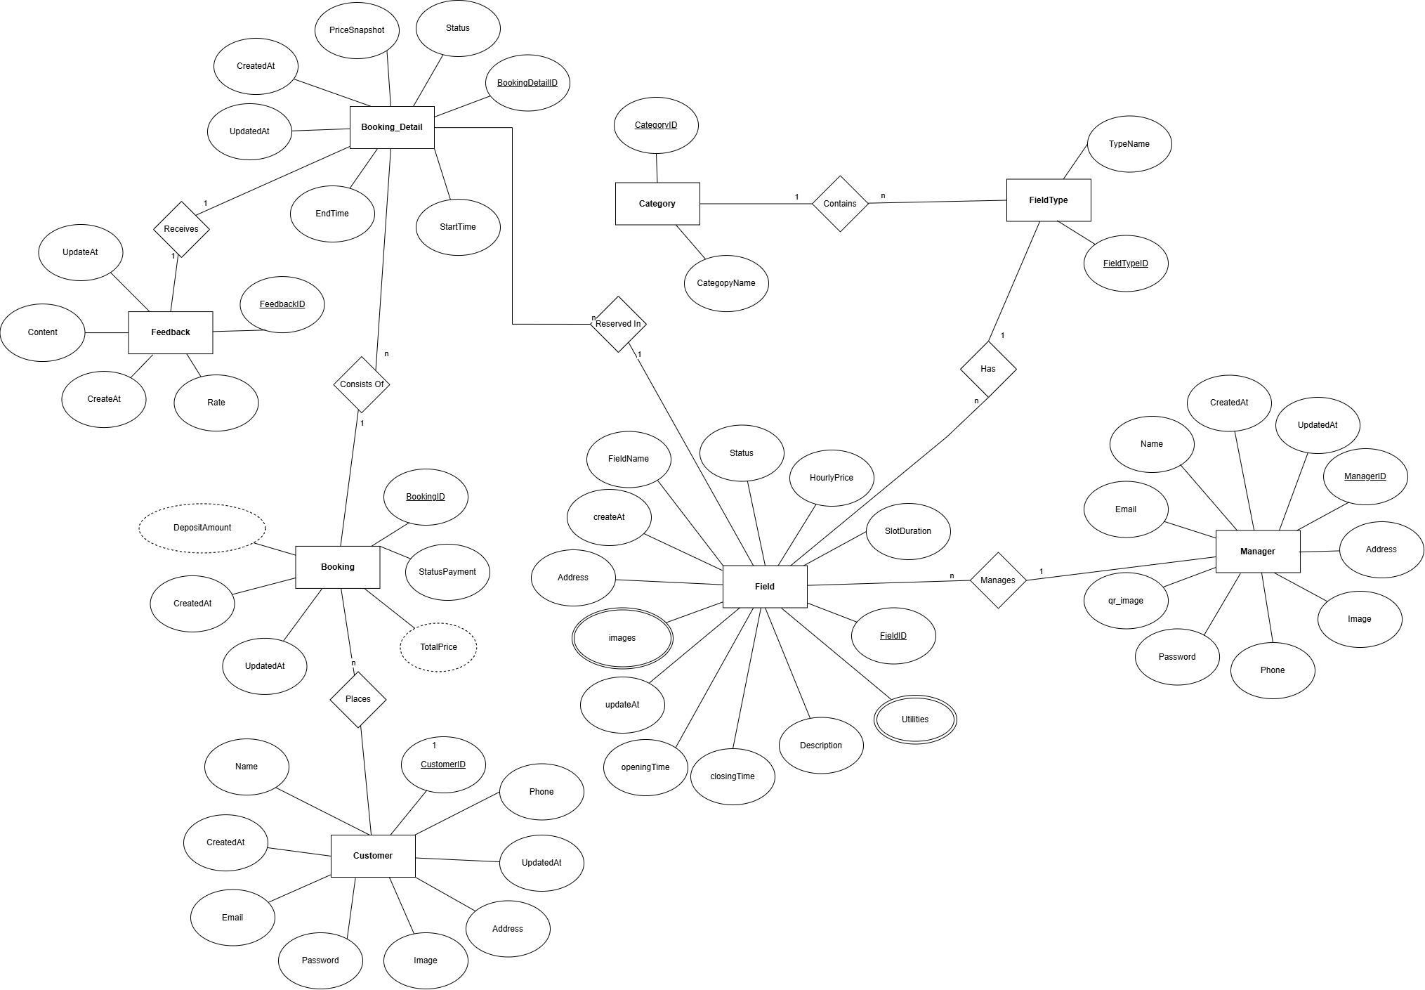
Figure I.9: Entity Relationship Diagram
Table I.6: Entities Description
# | Entity | Description
1 | Customer | Represents the end-user of the system. Stores personal information (CustomerID, Name, Email, Phone, Address, Password, Image) and timestamps (CreatedAt, UpdatedAt). This entity is responsible for initiating reservations (via the Places relationship with Booking).
2 | Manager | Represents the facility owner or manager. Directly manages the fields (Field). Stores personal and administrative information (ManagerID, Name, Email, Phone, Address, Password, Image, qr_image) along with timestamps.
3 | Category | Represents the high-level classification of sports or services offered (e.g., Football, Badminton). Contains the basic attributes CategoryID and CategoryName. A Category can contain multiple FieldTypes.
4 | FieldType | Defines the specific configuration or variation of a sport field (e.g., "5-a-side", "7-a-side"). It only includes FieldTypeID and TypeName.
5 | Field | Represents the actual, physical court or pitch available for rent. It contains numerous detailed attributes: FieldID, FieldName, Address, operating hours (openingTime, closingTime), rental rate (HourlyPrice), time per slot (SlotDuration), Status, and Description. It also features multivalued attributes (double ovals) like images and Utilities.
6 | Booking | Represents the overall booking transaction for the customer. Stores BookingID, payment status (StatusPayment), and derived attributes (dashed ovals) such as DepositAmount and TotalPrice.
7 | Booking_Detail | Stores the granular details of each specific reservation slot. Specifies the StartTime, EndTime, the price at the time of booking (PriceSnapshot), and Status. It is directly linked to a specific Field (via the Reserved In relationship).
8 | Feedback | Captures post-service reviews from customers. Stores the rating (Rate), textual comments (Content), and timestamps. It has a 1-to-1 relationship with a specific Booking_Detail (via the Receives relationship).

II. Functional Requirements

1. Login
Table II.1: Login feature
USE CASE-01
Use-case No. | UC01 | Use-case Version |  | 1.0
Use-case Name | Login
Author | Sang
Date | 18/1/2026 | Priority | High
Actor | Customer, Manager
Summary | Allows customers/managers to log in to access system features.
Goal | Authenticate users and grant access to role-specific interfaces.
Triggers | The user clicks the "Login" button on the navigation bar.
Preconditions | Actor is not logged in. Actor has a valid registered account.
Post Conditions | Actor is authenticated. System grants access based on role (Customer/Manager)
Main Success Scenario
Step | Actor Event |  | System response
1 | - Actor enters email and password |  | System validates input format.
2 | - Actor clicks "Login" |  | System verifies credentials against the database, creates a JWT session, and redirects the actor to the Home page or Dashboard.
Alternative Scenario
Step | Action |  |  | Use case
Exception code | Exception code | Message | Caught
Exception code | 401 | Invalid email or password | When credentials do not match database records.
 | 403 | Account is locked | When an inactive or banned user attempts to log in
Business Rules | Code | Rule
Business Rules | BR-01 | Passwords must be verified using bcrypt hashing comparison.
Business Rules | BR-02 | User session expires automatically after 24 hours.

2. Logout
Table II.2: Logout feature
USE CASE-02
Use-case No. | UC02 | Use-case Version |  | 1.0
Use-case Name | Logout
Author | Sang
Date | 18/1/2026 | Priority | High
Actor | Customer, Manager
Summary | Allows customers or managers to log out of the system.
Goal | End the current session and return to the Guest state securely.
Triggers | The actor clicks the "Logout" button in the profile menu.
Preconditions | The actor is currently logged in.
Post Conditions | Session is terminated.
Main Success Scenario
Step | Actor Event |  | System response
1 | Actor clicks Logout |  | System clears session tokens and local storage data.
2 | System completes clearing process |  | Actor is redirected to the public Home page.
Alternative Scenario
Step | Action |  |  | Use case
Exceptions | Exception code | Message | Caught
Exceptions | 401 | Unauthorized | If a guest attempts to trigger the logout API.
Business Rules | Code | Rule
Business Rules | BR-03 | Logout must terminate the current JWT session immediately on the client side.
 | BR-04 | After logout, the actor must be redirected to the Guest homepage.

3. Sign up
Table II.3: Sign Up feature
USE CASE-03
Use-case No. | UC03 | Use-case Version |  | 1.0
Use-case Name | Sign Up
Author | Sang
Date | 18/1/2026 | Priority | High
Actor | Guest
Summary | Allows guests to create a new customer account.
Goal | Create a new authenticated customer profile in the system.
Triggers | Guest clicks the "Sign up" button.
Preconditions | The guest is not logged in.
Post Conditions | A new Customer account is created and saved in the database.
Main Success Scenario
Step | Actor Event |  | System response
1 | Guest enters registration information (Name, Email, Phone, Password) |  | System validates the input data format.
2 | Guest clicks "Register" |  | System checks for duplicate email/phone, hashes the password, creates the account, and redirects to the Login page.
Alternative Scenario
# | Action |  |  | Use case
Exceptions | Exception code | Message | Caught
Exceptions | 409 | Email already exists | When the entered email is already in the database.
 | 400 | Invalid registration data | When password is too weak or phone number format is wrong
 | 500 | Server error | Cannot create account
Business Rules | Code | Rule
Business Rules | BR-05 | Each email address and phone number can be used for only one account.
 | BR-06 | Passwords must contain at least 8 characters, including letters and numbers.

4. View Field List
Table II.4: View Field List feature

USE CASE-04
Use-case No. | UC04 | Use-case Version |  | 1.0
Use-case Name | View Field List
Author | Sang
Date | 18/1/2026 | Priority | Medium
Actor | Guest, Customer
Summary | Displays a list of available sports fields to users.
Goal | Allow guests or customers to browse all available fields.
Triggers | The actor clicks on "Fields" in the navigation menu.
Preconditions | None
Post Conditions | The paginated field list is displayed successfully.
Main Success Scenario
Step | Actor Event |  | System response
1 | Actor navigates to the field list page |  | System retrieves active fields from the database.
2 | System completes data retrieval |  | System displays field cards (Image, Name, Price, Location)
Alternative Scenario
# | Action |  |  | System response
Exceptions | Exception code | Message | Caught
Exceptions | 404 | No field available | If the database has no active fields.
 | 500 | Server Error | Cannot load field list
Business Rules | Code | Rule
Business Rules | BR-07 | Only fields with the status "Available" or "Active" are displayed to users.
 | BR-08 | Default sorting is by newest created (createdAt DESC).

5. View Field Detail
Table II.5: View Field Detail feature

USE CASE-05
Use-case No. | UC05 | Use-case Version |  | 1.0
Use-case Name | View field detail
Author | Sang
Date | 18/1/2026 | Priority | Medium
Actor | Guest, Customer
Summary | Displays detailed information of a selected field including time slots.
Goal | Provide detailed field information and availability schedules.
Triggers | The actor clicks on a specific field card.
Preconditions | The selected field exists in the database.
Post Conditions | Field details and interactive calendar are displayed.
Main Success Scenario
Step | Actor Event |  | System response
1 | Actor selects a field |  | System retrieves field information, reviews, and time slot schedules.
2 | System completes retrieval |  | System displays full details (Description, Amenities, Price, Map, and Slots).
Alternative Scenario
# | Action |  |  | Use case
Exceptions | Exception code | Message | Caught
Exceptions | 404 | Field not found | If the field ID does not exist.
 | 403 | Field is inactive | If the field is under maintenance
Business Rules | Code | Rule
Business Rules | BR-09 | Inactive fields cannot display bookable time slots.

6. Search Field
Table II.6: Search Field feature

USE CASE-06
Use-case No. | UC06 | Use-case Version |  | 1.0
Use-case Name | Search & Filter Fields
Author | Sang
Date | 18/1/2026 | Priority | Medium
Actor | Guest, Customer
Summary | Allows users to search for fields using keywords and filters.
Goal | Help users find suitable fields quickly based on specific criteria.
Triggers | Actor enters keywords or selects filters (Category, Location, Price).
Preconditions | None
Post Conditions | Filtered search results are displayed.
Main Success Scenario
Step | Actor Event |  | System response
1 | Actor enters search criteria |  | System processes the query and filters database records.
2 | System finishes query |  | System updates the UI with matching fields.
Alternative Scenario
# | Action |  |  | Use case
Exceptions | Exception code | Message | Caught
Exceptions | 400 | Bad Request | Invalid search criteria
 | 404 | No matching field found | When search criteria yield 0 results.
Business Rules | Code | Rule
Business Rules | BR-10 | Search algorithm must support filtering by Field Name, Sport Category, and District/Province.

7. Book Field
Table II.7: Book Field feature

USE CASE-07
Use-case No. | UC07 | Use-case Version |  | 1.0
Use-case Name | Book Field
Author | Sang
Date | 18/1/2026 | Priority | High
Actor | Customer
Summary | Allows customers to reserve time slots and create a booking invoice requiring a 30% deposit.
Goal | Successfully secure a field reservation and generate a payment request.
Triggers | Customer selects time slots and clicks "Book Now".
Preconditions | Customer is logged in. Selected time slots are available.
Post Conditions | Booking is created with 'Pending' status. Payment QR is displayed.
Main Success Scenario
Step | Actor Event |  | System response
1 | Customer selects slots and clicks Book |  | System verifies slot availability in real-time
2 | Verification passes |  | System calculates total price, creates a Booking record, locks the slots, and displays the Manager's payment QR code.
Alternative Scenario
- Alt Flow (Timeout): If the customer creates the booking ('Pending') but does not transfer the deposit within a defined time frame, the node-cron job will automatically mark the booking as 'Cancelled' and release the time slots.
 | Action |  |  | Use case
Exceptions | Exception code | Message | Caught
Exceptions | 409 | Slot already booked | If another user books the slot milliseconds before checkout.
 | 401 | Unauthorized | If the session expires during checkout.
Business Rules | Code | Rule
Business Rules | BR-11 | Customers cannot book time slots in the past.
 | BR-12 | A booking automatically expires if the deposit is not confirmed by the Manager within 24 hours.

8. Receive Notification
Table II.8: Receive Notification feature

USE CASE-08
Use-case No. | UC08 | Use-case Version |  | 1.0
Use-case Name | Receive Notification
Author | Sang
Date | 18/1/2026 | Priority | Medium
Actor | Customer
Summary | Delivers system alerts regarding booking status changes
Goal | Keep users informed about their transactions.
Triggers | Booking status is updated (e.g., Approved, Cancelled).
Preconditions | User has an active booking or interaction.
Post Conditions | Notification message is pushed to the UI.
Main Success Scenario
Step | Actor Event |  | System response
1 | Booking status changes in DB |  | System generates a notification payload.
2 | System pushes payload |  | Actor views toast/popup notification on their screen.
Alternative Scenario
# | Action |  |  | Use case
 | Booking processing |  |  | UC12
Exceptions | Exception code | Message | Caught
Exceptions | 500 | Server Error | If the notification server fails to push the message.
Business Rules | Code | Rule
Business Rules | BR-13 | Notifications must be linked directly to a specific Booking ID.

9. Manage Customer Profile
Table II.9: Manage Customer Profile feature

USE CASE-09
Use-case No. | UC09 | Use-case Version |  | 1.0
Use-case Name | Manage Customer Profile
Author | Sang
Date | 18/1/2026 | Priority | Medium
Actor | Customer
Summary | Allows customers to update personal information and avatar.
Goal | Maintain accurate and up-to-date user records.
Triggers | Customer clicks "Edit Profile" and submits new data.
Preconditions | Customer is logged in.
Post Conditions | Personal data in the database is updated.
Main Success Scenario
Step | Actor Event |  | System response
1 | Customer inputs new Name, Phone, and clicks Save |  | System validates the data (image size, phone format).
2 | Validation passes |  | System updates the database and displays a success message.
Alternative Scenario
# | Action |  |  | Use case
Exceptions | Exception code | Message | Caught
Exceptions | 400 | Invalid file format | If the avatar is not JPG/PNG or exceeds 5MB
Business Rules | Code | Rule
Business Rules | BR-14 | Email address cannot be changed after initial registration.

10. View booking list
Table II.10:View booking list feature

USE CASE-10
Use-case No. | UC10 | Use-case Version |  | 1.0
Use-case Name | View booking list
Author | Sang
Date | 18/1/2026 | Priority | High
Actor | Customer, Manager
Summary | Displays a comprehensive list of booking histories for the user.
Goal | Provide oversight of all past and current reservations.
Triggers | Actor navigates to the "My Bookings" or "Booking Management" tab.
Preconditions | Actor is logged in.
Post Conditions | A sorted list of bookings is displayed.
Main Success Scenario
Step | Actor Event |  | System response
1 | Actor accesses the page |  | System queries bookings associated with the Actor's ID.
2 | System returns data |  | System renders the list with Status badges (Pending, Confirmed, Cancelled).
Alternative Scenario
# | Action |  |  | System Response
Exceptions | Exception code | Message | Caught
Exceptions |  | "No bookings found" | If the user has never made a booking
Business Rules | Code | Rule
Business Rules | BR-15 | Customers can only view their own bookings. Managers can view all bookings related to their managed fields.

11. Manage booking field
Table II.11: Manage booking field feature

USE CASE-11
Use-case No. | UC11 | Use-case Version |  | 1.0
Use-case Name | Manage booking field
Author | Sang
Date | 18/1/2026 | Priority | High
Actor | Manager
Summary | Allows managers to Confirm Deposit (30%), Confirm Payment (70%), or Reject pending bookings.
Goal | Control field schedules and track revenue collection across multiple stages.
Triggers | Manager clicks action buttons on a booking record.
Preconditions | Manager is logged in. Booking is in a modifiable status.
Post Conditions | Booking status is updated, customer is notified.
Main Success Scenario
Step | Actor Event |  | System response
1 | Manager selects a 'Pending' booking, verifies the 30% bank transfer, and clicks "Confirm Deposit" |  | System updates status to 'Confirmed'.
2 | Customer finishes using the field |  | Manager selects the 'Confirmed' booking, verifies the remaining 70% payment, and clicks "Confirm Payment" -> System updates status to 'Completed'
Alternative Scenario
- If a booking is 'Confirmed' but the customer does not show up at the scheduled time, the manager can mark the booking as 'Cancelled' or 'No Show' (forfeiting the deposit).
Exceptions | Exception code | Message | Caught
Exceptions | 400 | Invalid action transition | If a Manager tries to confirm payment for a booking that hasn't had the deposit confirmed yet (skipping stages).
Business Rules | Code | Rule
Business Rules | BR-16 | Booking workflow strictly follows: Pending -> Confirmed -> Completed.

12. Manage FeedBack
Table II.12:Manage FeedBack feature

USE CASE-12
Use-case No. | UC12 | Use-case Version |  | 1.0
Use-case Name | Manage feedback
Author | Sang
Date | 18/1/2026 | Priority | Medium
Actor | Manager
Summary | Allows managers to view and analyze customer reviews.
Goal | Monitor service quality and handle inappropriate comments.
Triggers | Manager accesses the Feedback Management page.
Preconditions | Manager is logged in.
Post Conditions | Feedback is displayed; Manager can hide spam comments.
Main Success Scenario
Step | Actor Event |  | System response
1 | Manager views the feedback list |  | System fetches reviews linked to Manager's fields.
2 | Manager views the feedback list |  | System updates feedback visibility status and recalculates the average star rating of the field.
Alternative Scenario
# | Action |  |  | Use case
Exceptions | Exception code | Message | Caught
Exceptions | 403 | Forbidden | If Manager tries to delete feedback of fields they do not own.
Business Rules | Code | Rule
Business Rules | BR-17 | Hidden feedbacks are excluded from the public average rating calculation.

13. Manager field
Table II.13: Manager field feature

USE CASE-13
Use-case No. | UC13 | Use-case Version |  | 1.0
Use-case Name | Manage field
Author | Sang
Date | 18/1/2026 | Priority | High
Actor | Manager
Summary | Allows managers to add or edit physical facility locations (Leaflet maps) and operating hours.
Goal | Maintain accurate branch/location data for the business.
Triggers | Manager clicks "Add Location" or "Edit".
Preconditions | Manager is logged in.
Post Conditions | Facility location data is saved.
Main Success Scenario
Step | Actor Event |  | System response
1 | Manager inputs location details, map coordinates, and operating hours |  | System validates inputs.
2 | Manager clicks Save |  | System stores the location entity in the database.
Alternative Scenario
# | Action |  |  | Use case
Exceptions | Exception code | Message | Caught
Exceptions | 400 | Invalid Hours | f Closing Time is earlier than Opening Time.
Business Rules | Code | Rule
Business Rules | BR-18: | A physical field (Pitch) must belong to a defined Location/Address.

14. CRUD field
Table II.14: CRUD field feature

USE CASE-14
Use-case No. | UC14 | Use-case Version |  | 1.0
Use-case Name | CRUD field
Author | Sang
Date | 18/1/2026 | Priority | High
Actor | Manager
Summary | Allows managers to Create, Read, Update, or Delete actual bookable sports fields.
Goal | Manage the inventory and pricing of sports fields.
Triggers | Manager submits the Field form.
Preconditions | Manager is logged in. Locations and Categories are pre-configured.
Post Conditions | Field inventory is updated.
Main Success Scenario
Step | Actor Event |  | System response
1 | Manager enters field Name, Category, Price, and uploads Image |  | System validates uniqueness and price > 0.
2 | Manager submits |  | System saves the new field and makes it visible (if Active) to customers.
Alternative Scenario
# | Action |  |  | System response
1 | Field has active bookings |  | Prevent deletion
Exceptions | Exception code | Message | Caught
Exceptions | 409 | Field name exists | If a field with the same name exists at the same location.
Business Rules | Code | Rule
Business Rules | BR-19 | A field cannot be Deleted if it has upcoming 'Pending' or 'Confirmed' bookings. It can only be marked as 'Maintenance/Inactive'.

15. Manage customer account
Table II.15: Manage customer account feature

USE CASE-15
Use-case No. | UC15 | Use-case Version |  | 1.0
Use-case Name | Manage customer account
Author | Sang
Date | 18/1/2026 | Priority | High
Actor | Manager
Summary | Allows managers to view registered users and block/unblock accounts.
Goal | Maintain system security and handle violating users.
Triggers | Manager toggles the account status button.
Preconditions | Manager is logged in
Post Conditions | Customer account status is updated to Active or Banned.  Main Success Scenario:
Main Success Scenario
Step | Actor Event |  | System response
1 | Manager searches for a customer and clicks "Block" |  | System asks for confirmation.
2 | Manager confirms |  | System updates the user status in the DB, immediately invalidating the user's active session.
Alternative Scenario
# | Action |  |  | System Response
Exceptions | Exception code | Message | Caught
Exceptions | 403 | Cannot block admin | If a manager attempts to block another manager/admin account.
Business Rules | Code | Rule
Business Rules | BR-20 | Banned customers cannot log in or create new bookings.

16. View dashboard
Table II.16: View dashboard feature

USE CASE-16
Use-case No. | UC16 | Use-case Version |  | 1.0
Use-case Name | View dashboard
Author | Sang
Date | 18/1/2026 | Priority | Medium
Actor | Manager
Summary | Displays a visual overview of system performance using Recharts.
Goal | Provide quick insights into business operations.
Triggers | Manager logs in or navigates to the Dashboard page.
Preconditions | Manager is logged in.
Post Conditions | Charts and metric cards are rendered.
Main Success Scenario
Step | Actor Event |  | System response
1 | Manager opens Dashboard |  | System executes aggregation queries on the database.
2 | Queries return data |  | System renders UI cards (Total Fields, Total Customers, Total Bookings).
Alternative Scenario
# | Action |  |  | Use case
Exceptions | Exception code | Message | Caught
Exceptions |  | No data available | If the system has 0 transactions, empty charts are displayed.
Business Rules | Code | Rule
Business Rules | BR-21 | Dashboard metrics only calculate data associated with the logged-in Manager's specific facilities.

17. View revenue statistics (not yet implement)
Table II.17: View revenue statistics feature

USE CASE-17
Use-case No. | UC17 | Use-case Version |  | 1.0
Use-case Name | View revenue statistics
Author | Sang
Date | 18/1/2026 | Priority | Medium
Actor | Manager
Summary | Displays detailed financial charts showing revenue generated over time.
Goal | Track income and identify peak business periods.
Triggers | Manager selects a time range filter on the revenue chart.
Preconditions | Manager is logged in
Post Conditions | Revenue line/bar charts are updated.
Main Success Scenario
Step | Actor Event |  | System response
1 | Manager selects "This Month" filter |  | System calculates the sum of total prices for 'Completed' bookings within the date range.
2 | System processes calculation |  | System draws the updated chart using Recharts.
Alternative Scenario
# | Action |  |  | System Response
2 | No revenue in period |  |  | Display “No data” message
Exceptions | Exception code | Message | Caught
Exceptions |  | $0 Revenue | If no bookings were completed during the selected period.
Business Rules | Code | Rule
Business Rules | BR-22 | Revenue calculations ONLY include bookings with the status 'Completed'. 'Cancelled' or 'Pending' bookings are strictly excluded.

18. Reset Customer Password
Table II.19: Reset Customer Password feature

USE CASE-18
Use-case No. | UC18 | Use-case Version |  | 1.0
Use-case Name | Reset customer password
Author | Sang
Date | 18/1/2026 | Priority | Medium
Actor | Customer (Guest state)
Summary | Allows customers to request a password reset link via email.
Goal | Help customers recover lost account access securely.
Triggers | Customer enters email and clicks "Send Reset Link".
Preconditions | Customer must provide an email registered in the database.
Post Conditions | An email containing a secure token is dispatched.
Main Success Scenario
Step | Actor Event |  | System response
1 | Customer submits email |  | System verifies email existence and generates a secure reset token.
2 | System sends email |  | Customer clicks link, enters New Password -> System updates DB.
Alternative Scenario
# | Action |  |  | System Response
 | The customer enters an email address that is not registered in the system. |  |  | System displays an error message: "Email address not found. Please try again."
Exceptions | Exception code | Message | Caught
Exceptions | 404 | Email not found | If the email is not registered.
Exceptions | 400 | Token expired | If the reset link is used after 15 minutes.
Business Rules | Code | Rule
Business Rules | BR-23 | Reset tokens must expire 15 minutes after generation for security.

19. Reset Manager Password
Table II.19: Reset Manager Password feature

USE CASE-19
Use-case No. | UC19 | Use-case Version |  | 1.0
Use-case Name | Reset manager password
Author | Sang
Date | 18/1/2026 | Priority | Medium
Actor | Manager
Summary | Allows managers to securely reset their administrative access password.
Goal | Recover Manager accounts without compromising administrative security.
Triggers | Manager requests a password reset from the Admin Login portal.
Preconditions | Manager's email exists with Role = 'Manager'.
Post Conditions | Password is reset successfully.
Main Success Scenario
Step | Actor Event |  | System response
1 | Manager submits email |  | System verifies email and role, generates token, sends email.
2 | Manager sets new password via email link |  | System updates encrypted password in DB.
Alternative Scenario
# | Action |  |  | System Response
Exceptions | Exception code | Message | Caught
Business Rules | Code | Rule
Business Rules | BR-24 | Manager passwords must meet stricter complexity rules (uppercase, lowercase, numbers, special characters).

20. Change Password
Table II.20: Change Password feature

USE CASE-20
Use-case No. | UC20 | Use-case Version |  | 1.0
Use-case Name | Change Password
Author | Sang
Date | 18/1/2026 | Priority | Medium
Actor | Customer, Manager
Summary | Allows logged-in users to change their password manually.
Goal | Improve account security by facilitating routine password updates.
Triggers | User submits the Change Password form in settings.
Preconditions | User is logged in.
Post Conditions | Password is updated in the database.
Main Success Scenario
Step | Actor Event |  | System response
1 | User enters Current Password and New Password |  | System verifies Current Password using bcrypt.
2 | Verification passes |  | System hashes the New Password, saves it, and notifies the user.
Alternative Scenario
# | Action |  |  | System Response
Exceptions | Exception code | Message | Caught
Exceptions | 400 | Incorrect current password | If the old password provided does not match.
Business Rules | Code | Rule
Business Rules | BR-25 | The New Password cannot be exactly the same as the Current Password.

21. View booking details
Table II.21: View booking detail feature

USE CASE-21
Use-case No. | UC21 | Use-case Version |  | 1.0
Use-case Name | View booking details
Author | Sang
Date | 18/1/2026 | Priority | Medium
Actor | Customer
Summary | Displays granular details of a specific invoice/booking.
Goal | Let customers review payment status, time slots, and field rules.
Triggers | Customer clicks "View Details" on a booking card.
Preconditions | Customer is logged in and owns the booking.
Post Conditions | Detailed booking modal/page is displayed.  Main Success
Main Success Scenario
Step | Actor Event |  | System response
1 | Customer clicks on booking |  | System queries specific Booking ID along with joined Field data.
2 | System returns data |  | UI renders total price, 30% deposit required, Manager's QR code, and chosen slots.
Alternative Scenario
# | Action |  |  | System Response
2a | The booking ID does not exist in the database. |  |  | System displays: "Booking not found."
2b | The booking belongs to a different customer account. |  |  | System denies access and displays: "You are not authorized to view this booking."
Exceptions | Exception code | Message | Caught
Exceptions | 403 | Access Denied | If a customer attempts to access a Booking ID belonging to another user.
Business Rules | Code | Rule
Business Rules | BR-26 | Booking details must clearly show the required Deposit amount (30% of total price).

22. Cancel booking
Table II.22: Cancel booking feature

USE CASE-22
Use-case No. | UC22 | Use-case Version |  | 1.0
Use-case Name | Cancel booking
Author | Sang
Date | 18/1/2026 | Priority | Medium
Actor | Customer
Summary | Allows a customer to void a reservation request.
Goal | Free up field slots if the customer changes their mind before paying the deposit.
Triggers | Customer clicks "Cancel Booking" and confirms.
Preconditions | Booking status is 'Pending' (or within allowed cancellation policy).
Post Conditions | Booking is marked 'Cancelled' and slots are released.
Main Success Scenario
Step | Actor Event |  | System response
1 | Customer confirms cancellation |  | System updates booking status to 'Cancelled' in DB.
2 | System releases the locked Time Slots back to 'Available' |  | System notifies the Manager.
Alternative Scenario
# | Action |  |  | System Response
 | Alt Flow (No Refund): If the customer cancels a booking that is already 'Confirmed' (deposit paid). |  |  | The system displays a warning that the 30% deposit is non-refundable.
Exceptions | Exception code | Message | Caught
Exceptions | 400 | Cannot cancel | If the booking is already 'Completed' or too close to the start
Business Rules | Code | Rule
Business Rules | BR-27 | Time slots associated with a Cancelled booking must be immediately released back to the public pool.

23. Create Feedback
Table II.23: Create Feedback feature

USE CASE-23
Use-case No. | UC23 | Use-case Version |  | 1.0
Use-case Name | Create feedback
Author | Sang
Date | 18/1/2026 | Priority | Medium
Actor | Customer
Summary | Allows customers to rate and review a field after usage.
Goal | Collect user satisfaction data to display to future customers.
Triggers | Customer submits the Feedback form.
Preconditions | The Booking status must strictly be 'Completed'.
Post Conditions | Feedback is saved and field rating is updated.
Main Success Scenario
Step | Actor Event |  | System response
1 | Customer selects 1-5 stars, writes a comment, and submits |  | System validates input.
2 | System saves the Comment entity |  | System recalculates the Field's average star rating.
Alternative Scenario
# | Action |  |  | System Response
Exceptions | Exception code | Message | Caught
Exceptions | 403 | Booking not completed | If the user tries to review a 'Pending' or 'Confirmed' booking before using the field.
Exceptions | 400 | Review already exists | If the user tries to review the same Booking ID twice.
Business Rules | Code | Rule
Business Rules | BR-28 | Only one feedback submission is allowed per completed booking.

24. Manage Manager Profile
Table II.24: Manage Manager Profile feature

USE CASE-24
Use-case No. | UC24 | Use-case Version |  | 1.0
Use-case Name | Manage Manager Profile
Author | Sang
Date | 18/1/2026 | Priority | Medium
Actor | Manager
Summary | Allows managers to update their personal info and payment QR code via Cloudinary.
Goal | Ensure customers see accurate contact and banking details for deposits
Triggers | Manager saves changes in Profile settings.
Preconditions | Manager is logged in.
Post Conditions | Manager profile and payment QR are updated globally.
Main Success Scenario
Step | Actor Event |  | System response
1 | Manager uploads a new Bank QR Image and updates phone number |  | System processes image upload to Cloudinary.
2 | System receives image URL |  | System updates Manager record in DB and confirms success.
Alternative Scenario
# | Action |  |  | System Response
 | Manager uploads an image file that exceeds the allowed size or is an unsupported format. |  |  | System shows an error: "File must be a JPG/PNG image under 5MB."
Exceptions | Exception code | Message | Caught
Exceptions | 500 | Upload failed | If Cloudinary fails to process the image, the profile update is aborted.
Business Rules | Code | Rule
Business Rules | BR-29 | The uploaded QR code image must be globally linked so all future checkouts for this Manager's fields display the updated image.

